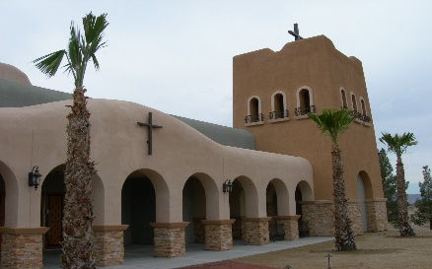
Our Lady of the Valley
Roman Catholic Church
781 E. Gamebird Road, Pahrump, Nevada 89048
Phone (775) 727-4044 our_lady781@yahoo.com Roman Catholic Archdiocese of Las Vegas
Baptism

WHAT IS THE ROLE OF PARENTS AND GODPARENTS?
Both parents and godparents are responsible for the upbring of the spiritual life of the newly baptized. That is why we require both to attend a class. The date of the class will be given in English every first Friday of the month at 5:30 pm, in Spanish every third Sunday of the month at 1:00 pm
Baptisms are performed once a month on Saturdays at 11:00am

BAPTISM REQUIREMENTS

Parents need to be members of our parish either by registration and regular attendance of mass.
Copy of the original birth certificate.
Parents and godparents have to take a baptismal class.
Parents and godparents have to fill out form.
The godparents have to:
Be Catholics
Be over the age of 16.
Have the sacraments of Baptism First Communion and Confirmation.
If the godparents are a couple, they must be married in the Church.
Children over 7 years of age must register for religious education classes. They cannot be baptized until they complete religious education classes.

